Incorporating Viral DNA into the CRISPR array of S. Thermophilus; Producing Bacteriophage Insensitive Mutants

MMG 408 Section 1

Devin Carree, Hai Truong, Keyur Patel

December 2, 2019

**Introduction**

There are more bacteriophages on earth than every other organism in the world combined. It is estimated to be approximately 1031bacteriophages in the world (1). If this is the case, then it should be possible for bacteriophage to infect the entire world and rid the world of bacteria, but this is not true. This is because like some higher-level organisms, bacteria exhibit adaptive immunity (2). Some of these mechanisms include adsorption-blocking, superinfection exclusion (Sie), restriction-modification systems abortive infection systems (Abi) and, clustered regularly interspaced short palindromic repeats (CRISPRs) (3). This study shows an increase in size of bacterial chromosome in CRISPR array of bacteriophage insensitive mutants (BIMs). Resulting in resistance of phage in bacteria.

CRIPSR is natural adaptive immunity that allows for sequence specific protection or regulation of DNA (2). In the bacterial genome, the CRISPR locus is a CRISPR array; there are many short direct repeats, separated by distinct DNA sequences (spacers) followed by many CAS genes. These spacers, variable DNA regions in between repeats, are viral DNA that the bacteria have incorporated into its own chromosome so this DNA can be detected and eliminated by proteins of the CAS genes. There are three stages involved in this evolution of resistance: adaptation, expression and interference (4). Adaptation is the incorporation of the sequence of DNA, needed to recognize the viral invader, into the genome of the bacteria. Expression is the stage where pre CRIPSR RNA (crRNA) is created and processed into mature crRNA used to guide CAS proteins to the viral target. And lastly interference where crRNA guides CAS proteins to the viral target to destroy them. This research hopes to gain insight on all three stages of this immunity in hopes to further research ideas that include CRIPSR arrays such as bacterial immunity or genetic regulation in some laboratory studies.

In this study the we show the concentration of the phage propagated using reverse titration calculations to find multiplicities of infection (MOI). This study also shows the propagation of BIMs after long term viral infection. We hope to understand the mechanism of the viral immunity by studying the genome of these BIMs. When viral infection in a bacterial colony occurs for a long period of time some bacteria can gain resistance through horizontal gene transfer. We hypothesize that within the CRISPR array, there are spacers in bacterial genome that correspond to the to a specific viral DNA and serves as a “memory” in the immune system for subsequent viral infections. This study shows this through increased size of genome and DNA sequencing of BIMs.

**Methods**

**Propagation of Bacteriophage**

In this study we propagated bacteriophage in order to infect the bacteria used to create BIMs. We used Bacteriophage 2972. To do this we followed the experimental protocol (3).

**Propagation of Bacteriophage Insensitive mutant**

We used bacteriophage 2972 to infect bacteria on an agar plate. The bacteria we used was *Streptococcus thermophilius* DGCC7710. To do this we followed the experimental protocol (3).

**Primer Design**

To create PCR products that contains the entire CRIPSR array including non-variable components of the loci we designed primers using NCBI primer design software. To do this we followed the experimental protocol (3).

**DNA Sequencing & Bioinformatics**

We sequenced the DNA of the BIMs to determine the sequence of the added section of DNA in the CRISPR array. To do this we followed the experimental protocol (3).

**Results**

The results obtained in this study include the propagation of plaque forming units, as well as the propagation of BIMs. We will compare both genomes and find the difference between them which should underline the genetic component of viral immunity

Using our bacteria *Streptococcus thermophilus* DGCC7710 we created a lawn on an agar plate which we subsequently infected with our phage. After successful propagationof PFUs we measured its efficiency as related to its concentration. Our PFU on the agar plates are positively correlated to the with the concentration of phage in the solution. This is seen in table 1 & figure 1.

Table 1: Phage dilution vs PFU

This table shows the number of plaques forming units formed when bacteria is infected with phage at varying concentrations.

|  |  |  |  |
| --- | --- | --- | --- |
| **Phage dilution** | **1.00E-05** | **1.00E-06** | **1.00E-07** |
| pfu | 700 | 248 | 48 |

a.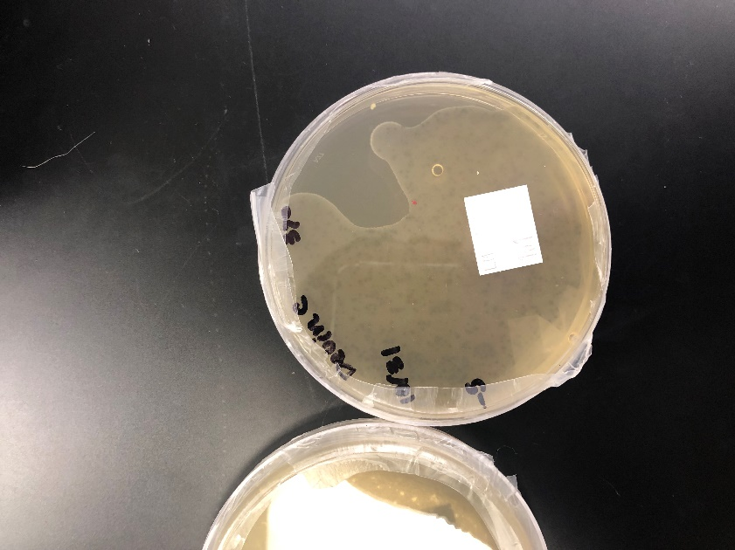 b.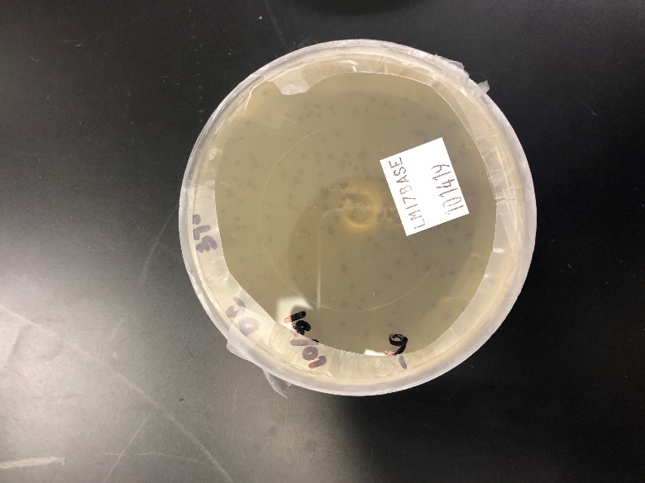 c.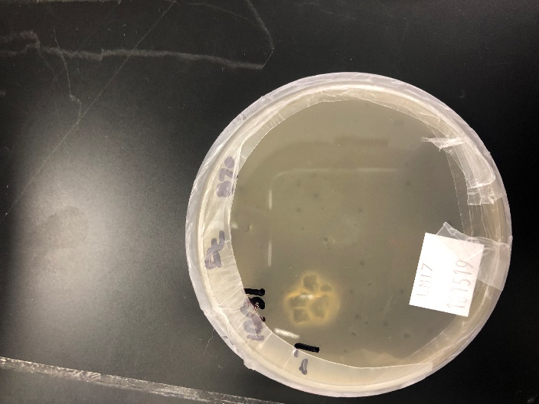

Fig 1. This figure shows a lawn of bacteria infected with bacteriophage. Each is associated with a different phage concentration. A) 10-5 B) 10-6 C) 10 -7

After long term infection of bacteria and clearing of bacterial lawn we see the propagation of single colonies. These colonies are uninfected by the phage. We see them in figure 2. 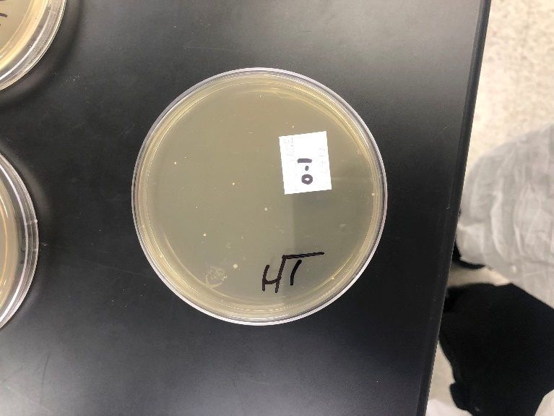 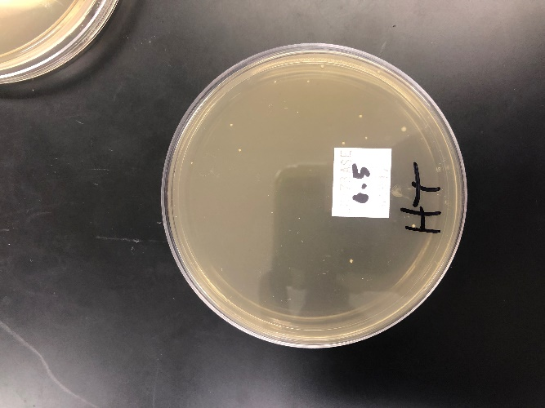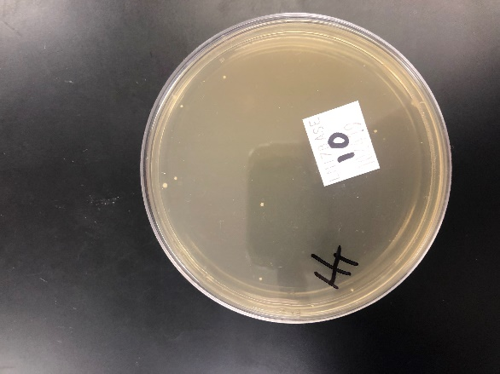

Fig. 2: This figure shows propagation of BIMs or bacteria that are resistant to infection by phage.

After we determined and isolated these bacterial cells, we culture them and propagated them along with more phage. As compared to the wild type (WT) cells the BIMs did not suffer any lysis due to the phage added and formed no PFUs. This is seen is figure 3.

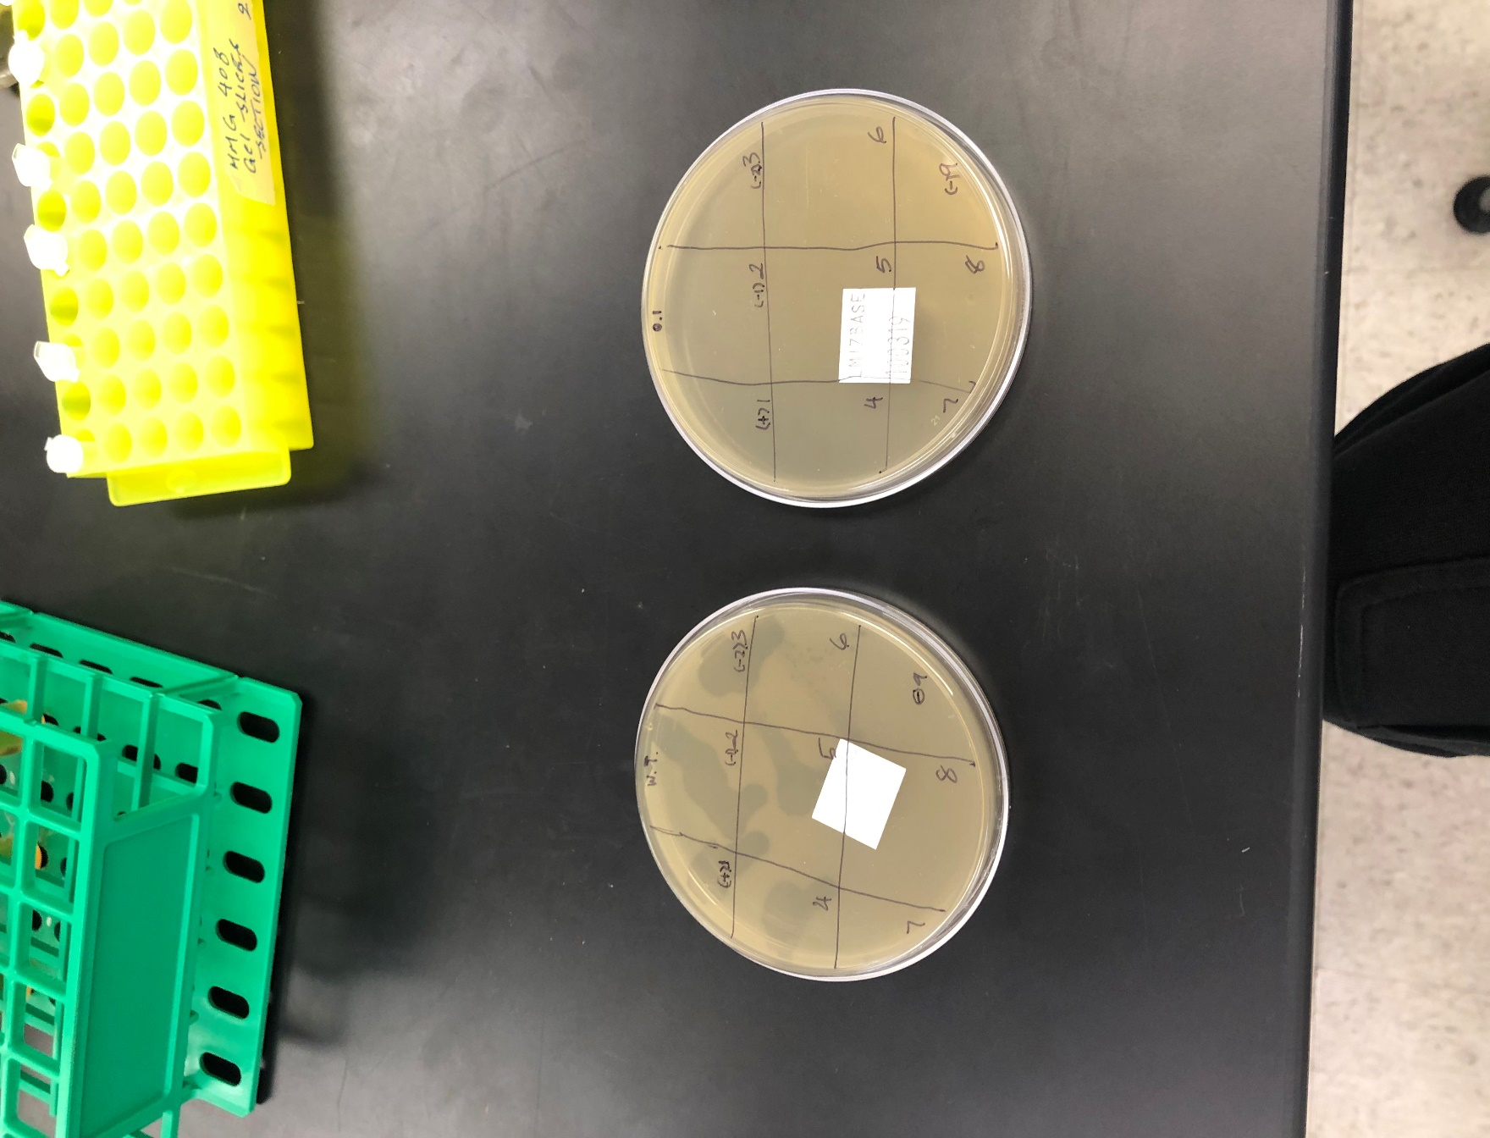

Fig. 3: This figure shows to bacterial plates grown with phage infection in both plates. One plate is grown with the WT type bacteria while the other was grown with BIMs from a plate with a MOI of 0.1.

We lysed the cells of the BIMs and purified their DNA to find the incorporated aspect of their genome that gives rise to this viral immunity using DNA sequencing. Using NCBI databases we compared the genome of the WT bacteria susceptible to viral infection and lysis to the genome of BIM with resistance. We found that in the wild type CRISPR array there are only 6 spacers, while in the BIM’s CRISPR array there are 7 spacers. This is seen in figure 4

a.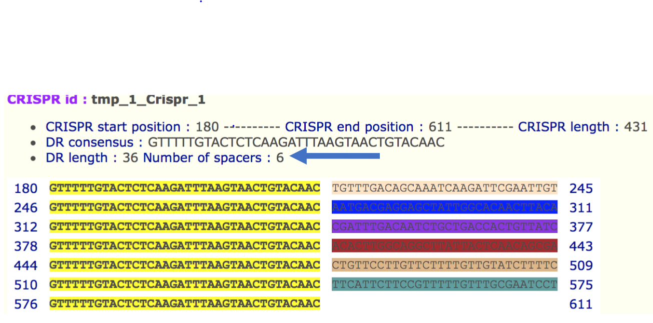

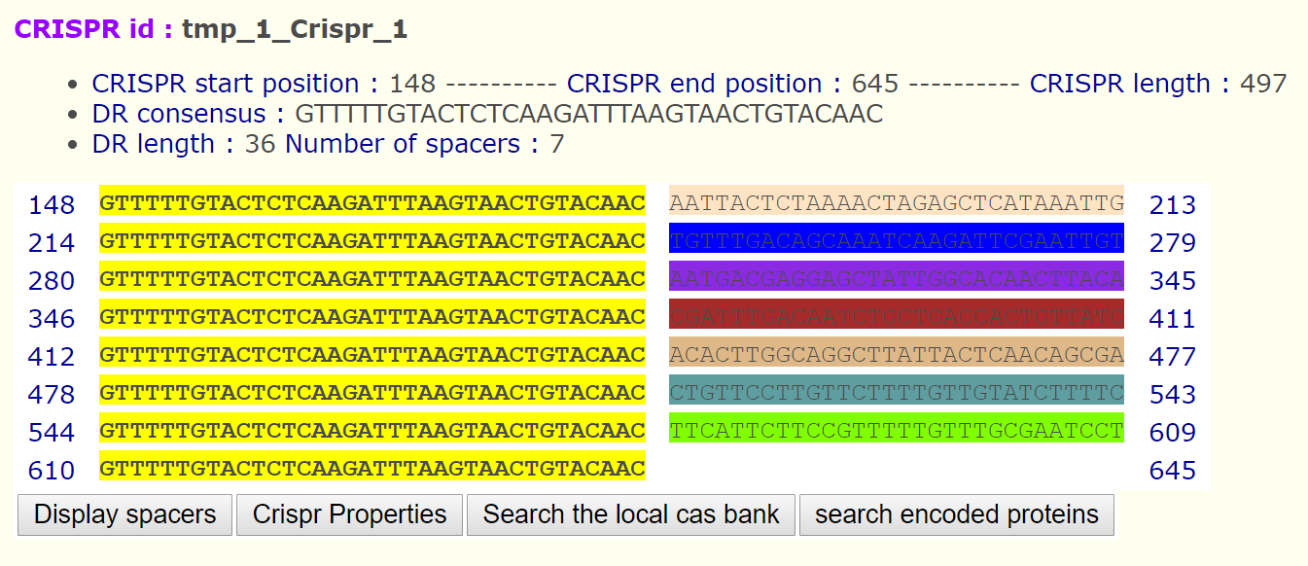

Fig. 4: This figure shows the same bacteria with similar DNA excluding one spacer. A) Is the WT DNA with only 6 spacers not immune to viral infection while B) Shows the DNA makeup of the BIM with 7 spacers which displays viral immunity.

The nucleotide sequence of the DNA incorporated into the genome of the bacterial insensitive mutant is AATTACTCTAAAACTAGAGCTCATAAATTG. The viral protein that the is correlated with this sequence is by a 150-polypeptide long protein, a terminase small subunit.

**Discussion**

This study shows that the phage was very effective at infecting and lysing the bacteria in the agar plate. At every concentration the bacteriophage was able to infect and cause a significant number of PFUs in the plates, this is seen in figure 1. After long term infection of bacteria with plaques they can effectively eliminate the entire lawn of bacteria leaving only single colonies of bacteria, this is seen in figure 2. These single colonies are insensitive to infection from the phage. This is due to the horizontal gene transfer of phage’s DNA into the genome of the bacteria. We expect this to be contributed to the natural immunity of the bacteria, known as the CRISPR-CAS system. In this system the bacteria transcribe guide RNA (crRNA) along with CAS proteins that act as nuclease to degrade viral RNA and DNA (4). Because this DNA is incorporated into the genome of the bacteria, we expect to also see this immunity in the progeny of the same bacteria. This can be seen in figure 3 when we compare the lawn of BIMs to a lawn of WT bacteria. In the plate with WT bacteria we see formation of PFU indicating that the phage was able to infect the bacteria effectively and lyse many of the cells at every concentration. The agar plate containing the BIMs propagated no PFUs even at the highest concentration of phage infection. This means that every bacterium in the plate has this immunity and it is located within the genome. This study uses bacteria *Streptococcus thermophilus,* but this immunity is not exclusive to one type of bacteria. As shown in other studies, we see the same in models of *E. coli,* acquisition of spacers following long term infection of phage that results in viral immunity (6). In our bacteria, using DNA sequencing we were able to track the immunity to a 30-nucleotide long spacer. This spacer is related to a 150-polypeptide long viral protein, a terminase small subunit. A terminase is an enzyme that introduces nicks into the virions own DNA to make cohesive ends to make mature virion DNA (7). Once mature crRNA that is associated with the memory of the terminase is created, the CAS proteins co-translated will be able to degrade all the DNA/RNA used to create that terminase. This will inhibit the virus from transcribing its own machinery to live effectively killing the virus and offering the bacteria immunity.

Although the CRISPR-CAS system is used in bacteria for immunity again viral infection it may hold great potential in human medicine and as well as animal genetic engineering. Although it is only been discover for a few years some scientists in China may be already experimenting with human trials, subjecting the first children to be born genetically edited by CRISPR, despite being very unethical (this study is unpublished). Strides are being made to make this an ethical reality such as using CRISPR-CAS systems for genomic editing, simple genetic experiments or for something as complex as studying stem cells (8).

**Work Cited**

1. "Novel Phage Therapy Saves Patient with Multidrug-Resistant Bacterial Infection". *UC Health – UC San Diego*. Retrieved 13 May 2018.
2. Makarova KS, Wolf YI, Alkhnbashi OS, Costa F, Shah SA, Saunders SJ, Barrangou R, Brouns SJJ, Charpentier E, Haft DH, Horvath P, Moineau S, Mojica FJM, Rebecca M, Terns MP, White MF, Yakunin AF, Garrett RA. 2017. 2015 CRISPR Review 13:722–736.
3. Kashefi, K. 2019. MMG 408. EXPERIMENTS I – III: Experiment I: Bacterial Growth and Induction of Bacterial Operons, Bacterial Genetics Exponential Growth and Induction of the E. coli lac Operon
4. Barrangou R. CRISPR–Cas systems and RNA-guided interference. Wiley Interdiscip Rev RNA. 2013; 4:267–278. [PubMed: 23520078]
5. Garneau JE, et al. The CRISPR/Cas bacterial immune system cleaves bacteriophage and plasmid DNA. Nature. 2010; 468:67–71. [PubMed: 21048762]
6. Swarts DC, Mosterd C, van Passel MWJ, Brouns SJJ (2012) CRISPR Interference Directs Strand Specific Spacer Acquisition. PLOS ONE 7(4): e35888. <https://doi.org/10.1371/journal.pone.0035888>
7. Feiss M, Catalano CE. Bacteriophage Lambda Terminase and the Mechanism of Viral DNA Packaging. In: Madame Curie Bioscience Database [Internet]. Austin (TX): Landes Bioscience; 2000-2013. Available from: <https://www.ncbi.nlm.nih.gov/books/NBK6485/>
8. Liang, P., Xu, Y., Zhang, X. et al. Protein Cell (2015) 6: 363. https://doi.org/10.1007/s13238-015-0153-5